How to make DMC plugin

Visual Studio C# is needed to create plugin for DMC.

1. Run Visual Studio and create new Project.

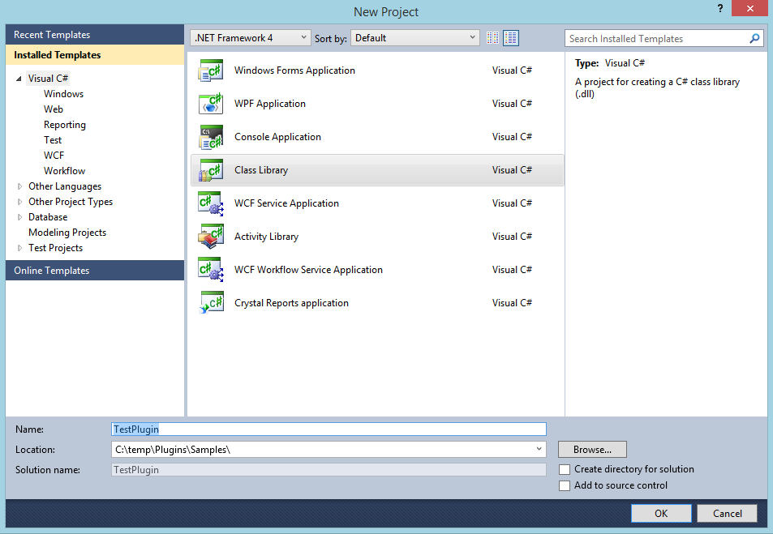

* Select project type “Class Library”
* Define project name. **Project name must contain word “Plugin”**. Only dll files with name containing word “Plugin” will be loaded.
* Select location where to save project

1. Add references to created project.

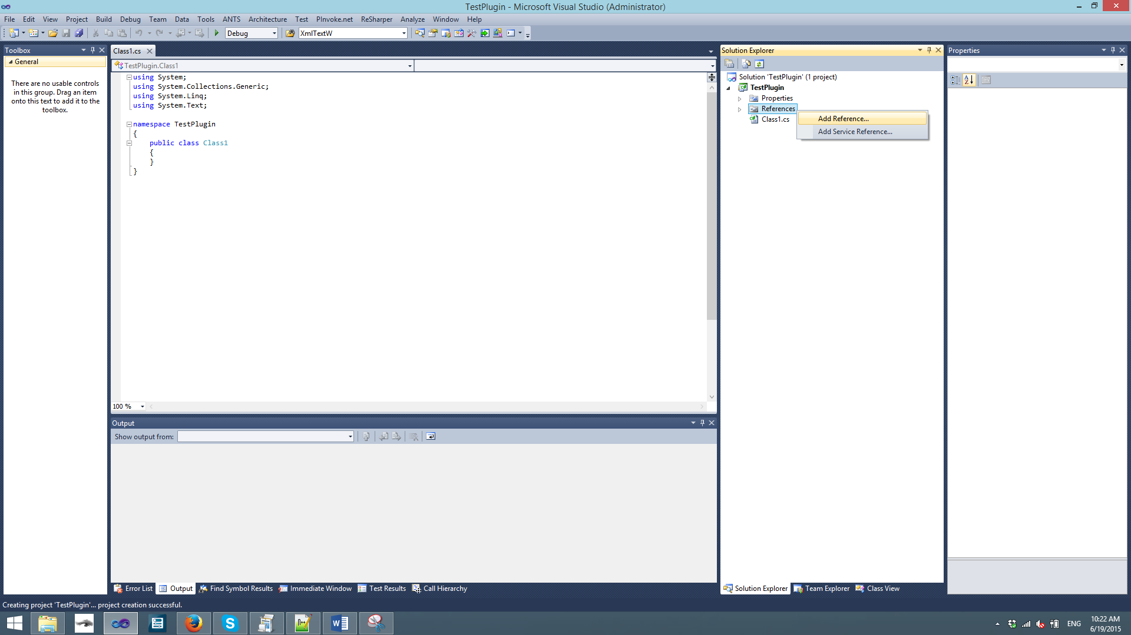

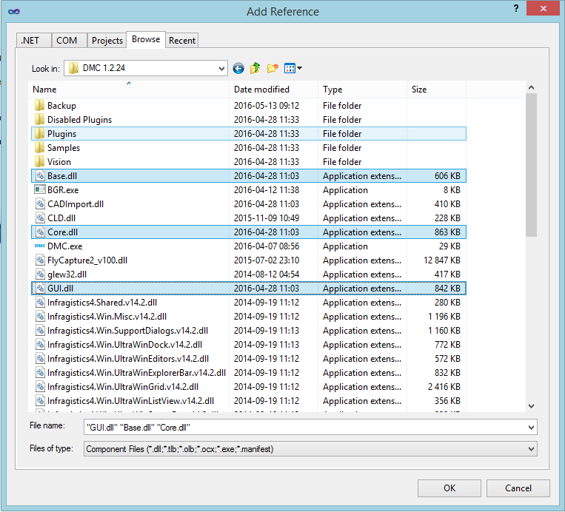

* **Base.dll**. Contains settings, interfaces (IAxis, , communicates with hardware, states.
* **Core.dll**. Contains interfaces of commands, commands (Line, Arc, ... ).
* **GUI.dll**. Contains top level functions that are used in main DMC window (Connect to hardware, Compile, Run, Stop, ... ), also has methods for adding/hiding custom buttons. .

1. Select added references and set Copy Local to False.

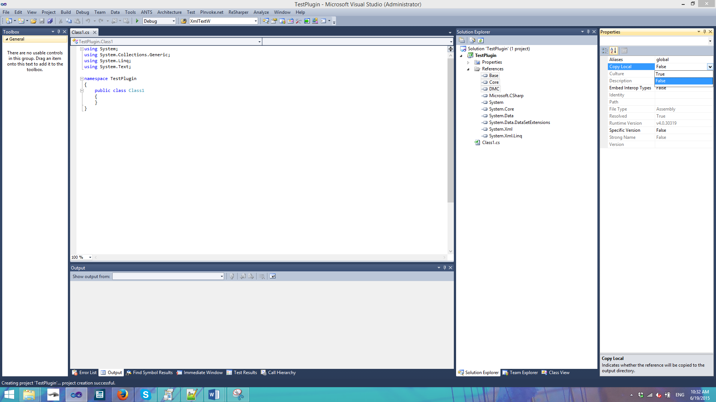

1. Go to Project settings and change project “Output path” to DMC path + Plugin directory. E.g C:\Program Files\DMC\DMC 1.1.9\Plugins\

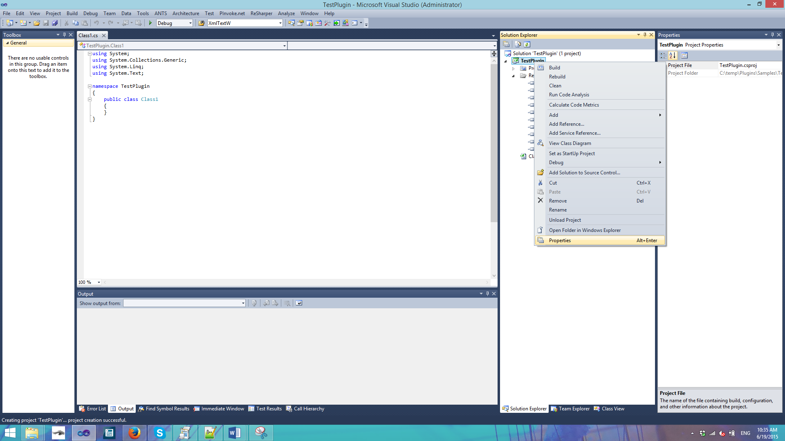

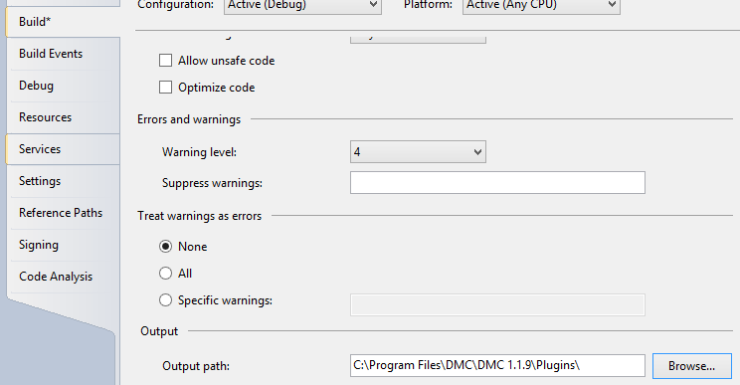

1. Add DMC.exe to solution. Right click on solution, click Add->Existing project and browse for DMC.exe.

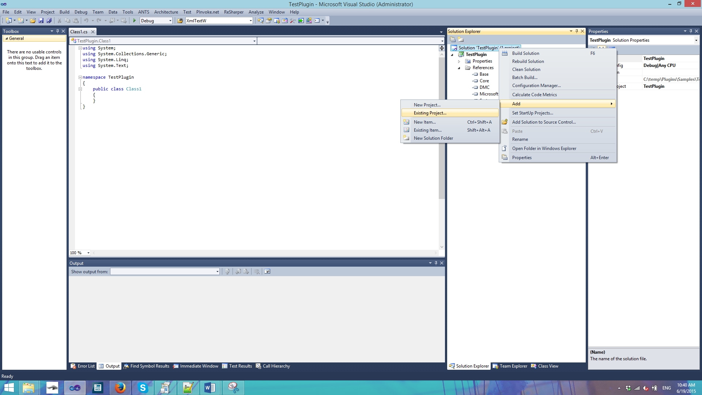 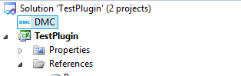

1. Set DMC as StartUp Project

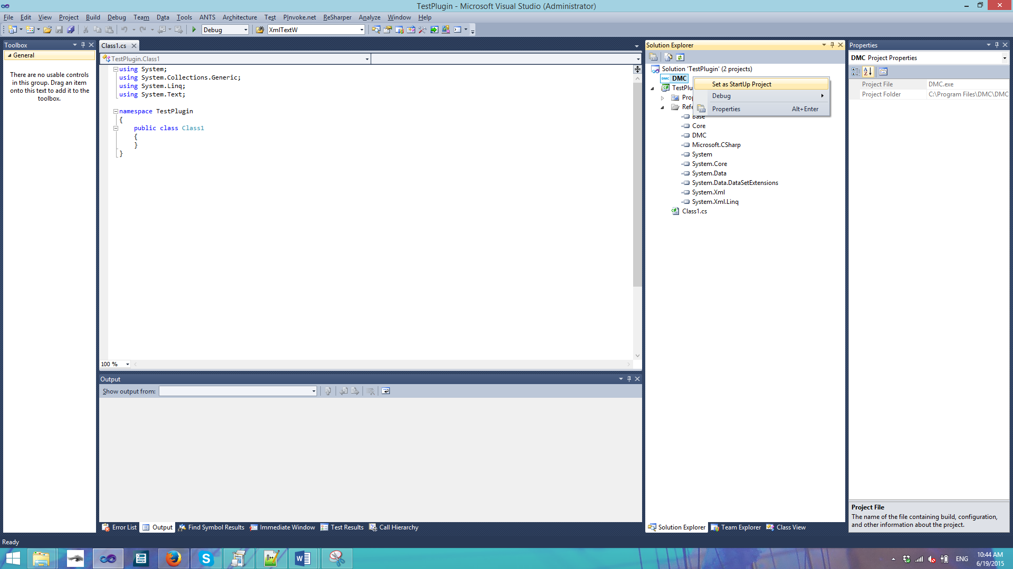

1. Add Reference System.Windows.Forms and make code:

using System;

using System.Collections.Generic;

using System.Linq;

using System.Text;

using Base;

namespace TestPlugin

{

// Class name must be public, contain Plugin word, must inherit IDevice interface, can't be abstract

public class MyPlugin : IDevice

{

public MyPlugin()

{

// Change DMC main form title

DMC.Form1.main.Text += " with my plugin";

}

// Action when user clicks Connect to hardware and IsEnabled is true

public bool Connect() { return true; }

// Action when user clicks Disconnect from hardware

public void Disconnect() { }

// Action when user clicks Stop button

public void Stop() { }

public string GetName() { return "My Plugin"; }

// Action when changes to settings are confirmed or loaded during DMC startup

public bool ApplySettings() { return true; }

// Needs to return if device is connected

public bool IsConnected() { return false; }

// Is device is enabled

public bool IsEnabled() { return false; }

// Called before starting recipe

public bool OnRecipeStart() { return true; }

// Called after recipe is finished or stopped

public void OnRecipeFinish() { }

// Get device settings

public IDeviceSettings GetSettings() { return null; }

// Get error message ( is called if Connect returns false )

public string GetErrorMessage() { return Base.Functions.GetLastErrorMessage(); }

}

}

1. For debugging purpose add breakpoint.



1. Click Run. 